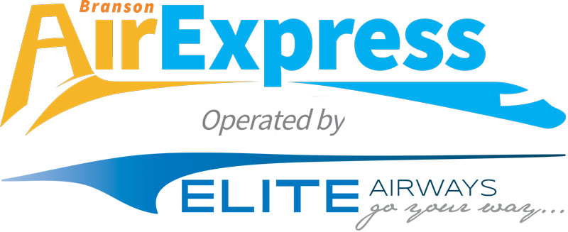

Branson Airport Contact
Jeffrey Bourk
Phone: 207-281-2684
jbourk@flybranson.com
NEWS RELEASE
FOR IMMEDIATE RELEASE:
Tuesday December 23, 2014

BRANSON RECEIVES AN EARLY CHRISTMAS GIFT FROM ELITE AIRWAYS AND BUZZ AIRWAYS
ANNOUNCING 4 NON-STOP DESTINATIONS ON BRANSON AIREXPRESS
Houston-Hobby (HOU) Airport Service will continue, while adding,
Denver (DEN), Chicago (MDW), and Austin (AUS)

BRANSON, MISSOURI (December 23, 2014) – Branson AirExpress operated by Elite Airways announced today they will be flying Houston (HOU) starting Feb 23rd and Denver (DEN) starting April 16th. Flights will be in a 50 seat CRJ-200 jet aircraft. Branson AirExpress operated by Buzz Airways will start service to Chicago (MDW), and Austin (AUS) on May 8th. Flights will be in a 30 seat Jetstream 41 aircraft.

One-way tickets, including taxes, can be purchased for:

City | Introductory Fare | Service Start Date
Branson – Houston-Hobby (HOU) | $159 | Feb 23, 2015
Branson – Denver (DEN) | $159 | April 16, 2015
Branson – Chicago (MDW) | $149 | May 8, 2015
Branson – Austin (AUS) | $149 | May 8, 2015
*see fare rules below

Flights to the four cities are available for purchase now at flybranson.com or BransonAirExpress.com.

The new flights operated by Elite Airways and Buzz Airways will replace service previously operated by other carriers. The flight schedule to all markets has been designed to allow customers to book separate tickets on other airlines in order to connect to/from popular gateways through all four cities.

Airlines operating at BKG have generated 1.1 million passengers since inception in 2009. US DOT data indicates about 65% of Branson Airport traffic is destination traffic (tourists coming to the area). The total economic impact from airport traffic on the area economy has been approximately $440 mm since 2009. The visitor spending alone from tourists has been about $217 mm (source document MODOT 2012 economic impact study).
“The 5 ½ years of Branson Airport’s existence has been a tumultuous period for the airline industry,” stated Jeff Bourk, Executive Director of Branson Airport. “Historically high jet fuel prices have led to unprecedented changes, including major capacity reduction, numerous airline bankruptcies and airline mergers. This in turn has caused significant negative impacts at airports around the country. Airports serving smaller markets have been affected most dramatically. Despite the fact that Branson air service has performed well, according to US DOT data, we have not been immune to changes in the airline industry. These industry changes have led to our two major carriers Southwest Airlines and Frontier airlines to choose to allocate their aircraft resources in other larger markets. This has created opportunity for Elite Airways and Buzz Airways,” said Bourk.
“Branson is a strong market, and is a test case for us. We believe what is happening at many of our nations smaller airports is creating an opportunity for Elite Airways,” stated John Pearsall, Chief Executive Officer of Elite Airways. “Expanding our schedule and operating in these markets makes a lot of sense. Other carriers such as Southwest Airlines and Frontier Airlines have proven the demand in Branson. This new schedule will give passengers lots of choices and access to the national air space system. If things continue to go well in Branson, we could further increase the capacity in this market as well as other areas of the country primarily in markets that have lost service similarly to Branson,” said Pearsall.

Book flights today at bransonairexpress.com or by calling 888-FLY-BKG1

*Fare Rules: Flights are public charters on FlyBranson Travel dba Branson AirExpress operated by Elite Airways and Buzz Airways. Advertised public charter fares are one-way, do not require a round trip purchase, and include Federal Excise Tax of 7.5%. These fares are capacity controlled and may not be available on all seats on all flights. The quoted charter price includes charter air transportation for the Charter Flight booked through BransonAirExpress.com or through the toll free Reservations Department at 1-888-FLY-BKG1 (1-888-859-2541). The first check bag will be $35.00 and the second checked is $35.00 per person. Each checked bag weighing over 50 pounds will be assessed a fee of $50 in addition to the checked bag fee. Dates of the advertised flights are subject to change in accordance with regulatory requirements. Cancellation is subject to administrative fee when permitted by regulatory requirements.
About Branson Airport:

Opening its doors May of 2009, Branson Airport LLC is the first privately developed and operated commercial service airport in the United States. Located in the heart of the Ozarks and centrally located in the Midwest, the airport also boasts a state of the art FBO, Branson JetCenter and a full service travel agency. For more information on Branson Airport LLC and any of its subsidiaries please visit FlyBranson.com.

About Elite Airways
Elite Airways was founded in 2006 by Airline veterans looking to provide a better travel experience for their passengers. Elite operates throughout the US, Canada, Mexico, Caribbean, and South America. Our experienced staff has operated aircraft for celebrities, heads of state, NASCAR, First Class Tour operators, Major League Baseball, National Basketball Association, National Football League, and various corporations. Elite flies a fleet of Bombardier CRJ-200 jet aircraft with seating for 50 passengers, and we are adding five more aircraft to our fleet this year.

